- Complete the fillable press release (PR) form and the pre-planning event checklist found on the employee resource page under the “Events” section. Do not use acronyms unless they are typed out.
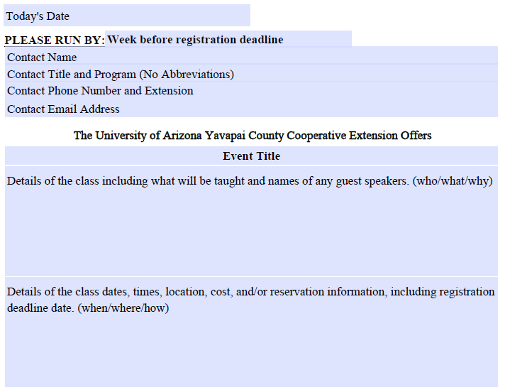
- Email yavapaipres@cals.arizona.edu and CC Mary Barnes at barnesm@email.arizona.edu. Attach the forms, flyers, and pictures you may have. For any special instructions, please include in the body of the message.
DON’T FORGET TO TAKE PHOTOS AT YOUR EVENT!
NOTES
- For a visual chart of the press release process, view the Events Planning Flowchart on the employee resource page.
- Additional checklists are available on the employee resource page to use the day before the event. This form is not required and was created to assist all programs with their events.
- It takes 24-48 hours for the event to post on the website.
- Some publications require the event to be sent out by the 15th of each month to appear in next month’s issue.

