Royalty free images are best to use when publishing flyers, on social media, or sending out press releases. The University of Arizona Creative Cloud does not have royalty free images.
- UArizona logos and brands (Your NetID is required) https://brand.arizona.edu/
- Arizona Pest Management Center – crops, weeds, and insects https://cals.arizona.edu/crop/images/images.html
- Free Photo Use Websites
  - https://pixabay.com/
  - https://unsplash.com/
- Royalty Free Photo Paid Subscriptions
  - Adobe Stock images (recommended): https://stock.adobe.com/plans
  - https://www.shutterstock.com/
Google Images has a wide variety of images for use but not all of them are royalty free. Below are instructions to filter results.
- In the upper right hand corner of the page, click on the drop down arrow next to SafeSearch. Click on “Filter explicit results”. The page will reload. Click on the down arrow again to ensure a check mark is next to the filter option.
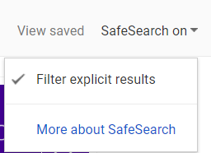
- On the ribbon at the top of the page, under the search bar, click on the “Tools” button. Click on the down arrow next to “usage rights” and select “labeled for reuse”.
