**Participant Instructions for logging into D2L Community Site**

Thank you for registering for the _______________________ class. The D2L Community site portal will be inaccessible to participants until ONE WEEK before the scheduled class date. At that time, review and follow the instructions below to log in to your account.

1. Enter the following address into a web browser. <https://community.d2l.arizona.edu/d2l/loginh/> *Save this web page to log in on the class dates.
2. Click **Public Participants.**
3. Enter your **email address** and type **“**pleasechange**”** into the password field**.**

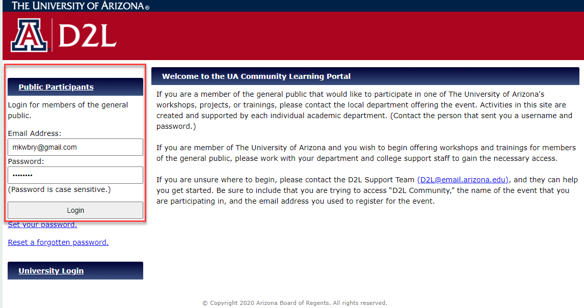

1. Once logged in, select your name top right, and select **Account Settings** from the menu.

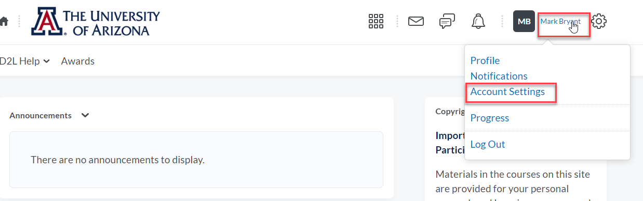

1. Select the **Change Password** link.

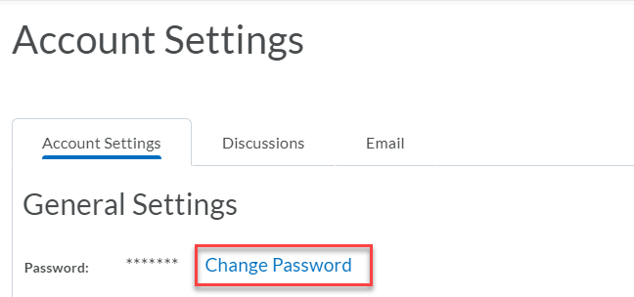

1. Enter the **old password “**pleasechange”, and enter your **new password**, and then **confirm the password**.  Click **Save**.

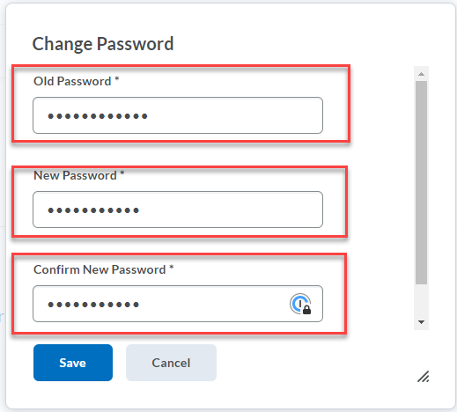

1. From the community D2L Home Page click on the course name tile to enter the class.

1. Explore the course content by viewing the announcements, content, discussions, and quizzes.

Frequently Asked Questions

**How do I navigate the D2L Community site?**

Here is a link to view a tutorial video that will guide you through the most used features of the D2L Community site. <https://arizona.hosted.panopto.com/Panopto/Pages/Viewer.aspx?id=0d72eb0d-f617-41d4-8c89-ac1e01576c23>

**How do I find my classes?**

Your courses are listed by semester on your Home Page. <https://help.d2l.arizona.edu/content/students-my-home-page>

**Help, I can't log in to D2L!**

If you experience problems logging in with your email and password, contact [d2l@arizona.edu](mailto:d2l@arizona.edu) or call 520-626-6804. Do not wait until the last minute to create your login and password. Our team cannot guarantee that we will get you logged in on time for class

**I'm registered for a class but my course doesn't appear in D2L!**

Courses automatically activate 1 week prior to the class start date; however, instructors can deactivate classes during this time to work on them. Please contact your instructor ____________ at _____________for additional questions or concerns.