Expense Reimbursement Request (EER) Procedures for Employees
- To submit a request for reimbursement, go to the employee resource page and click on the appropriate link to download and complete the fillable form within 2 business days of a purchase.
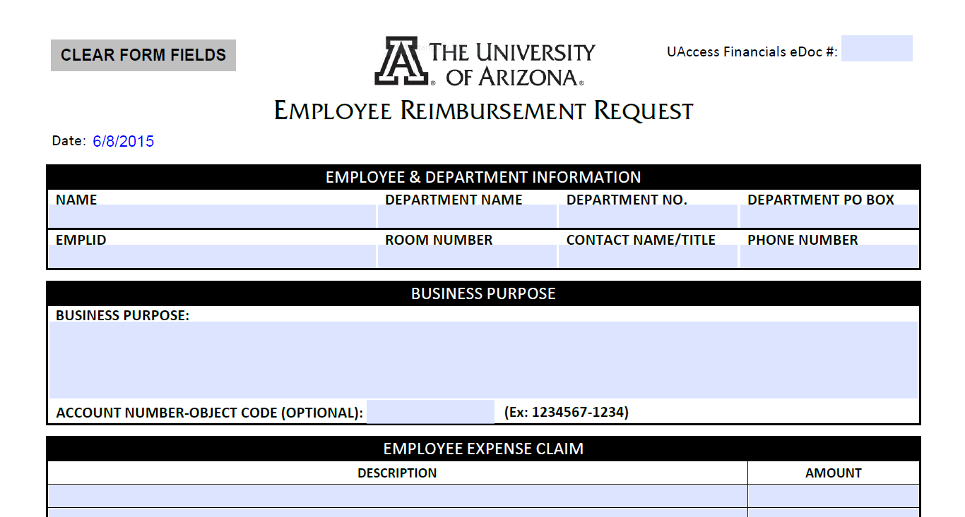
- If you are unable to complete the fillable PDF, you may print off the form and write the information in blue ink, then submit to your appropriate admin staff with all backup documentation.
- You may also give all required information and receipts to your support staff who can complete the ERR.
- Complete as much information as possible. When completing the Business Purpose section, you must provide justification for WHY the expenditure was incurred, how it benefitted the UA, and how it complied with all laws and regulations.
- Provide all support documentation (ie. receipts, agendas,) related to the dollar amount being requested for reimbursement to designated administrative staff in your office.
  - If you are submitting the form electronically, scan the backup documents and attach them to an email with the fillable form.
  - If you are submitting the form physically, paper clip the form to the backup documentation.
- Once the administrative staff has created the Disbursement Voucher (DV) in UAccess, you will be provided a link via email to sign the document electronically. VPN must be turned on to access Financials in UAccess.

