Department of Public Safety (DPS) Fieldprint Appointment Procedures
Before setting up an appointment with the receptionist, the Designated Campus Collegue (DCC) must begin the process through the program coordinator. They will need to provide information from a valid form of ID such as a driver’s license or passport because this will be compared and verified when they go to the appointment.
- Open an internet browser and go to the Fieldprint Arizona website https://fieldprintarizona.com/.
- If you are a new user:
  - Click the large purple button labeled Schedule an Appointment.
  - Enter the volunteer’s email address and click Sign Up.
- 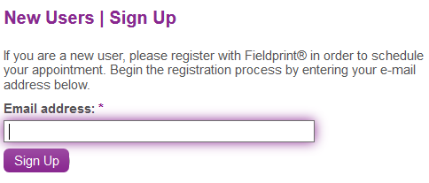
  - Enter the password – (your county’s chosen password OR Yavapai1!)
  - Enter the security question – What is our department number?
  - Enter the security answer – 1533 (if Coconino), 1538 (if Mohave), OR 1543 (if Yavapai)
  - Re-enter the volunteer’s contact email address.
  - Click Sign Up and Continue
  - When asked why to be fingerprinted, click Select next to Identity Verified Prints (IVP) – Volunteer or Student from the list of choices.
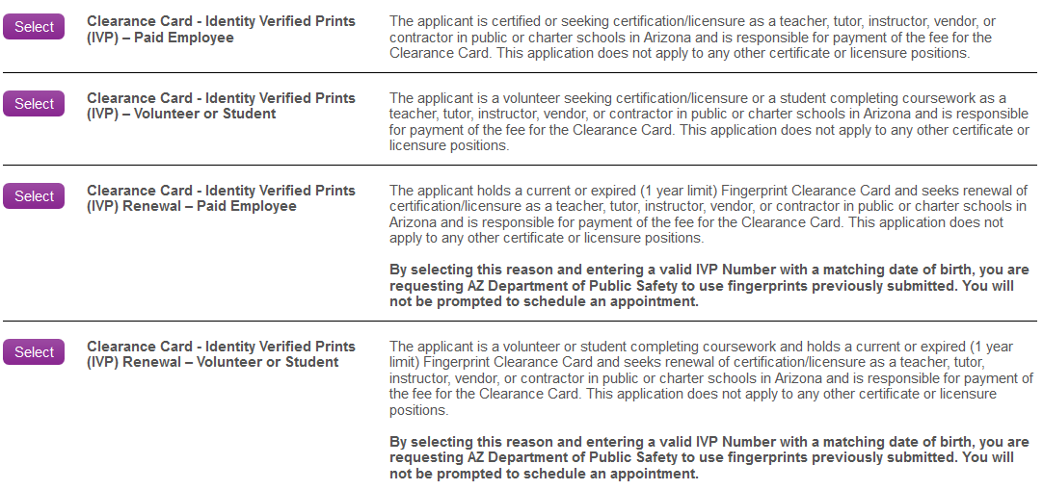
  - The next page will ask to verify the choice made from the previous page. Click Continue.
  - On the Sponsors page, check the box next to Public and/or Charter School Contractor, Subcontractor or Vendor and their Employees, then click Save and Continue.
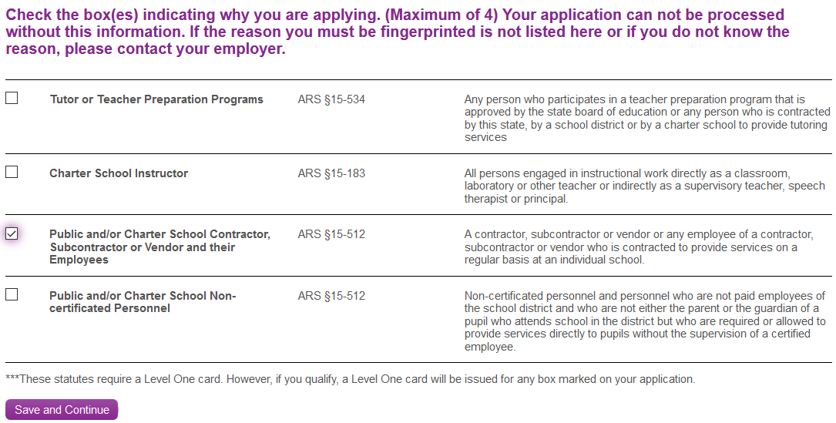
  - Continue to step 4 to continue the process.
- If you are a returning user:
  - Click the Login button at the top of the page.
  - Enter the volunteer’s email address and standard password. Then click Sign In.
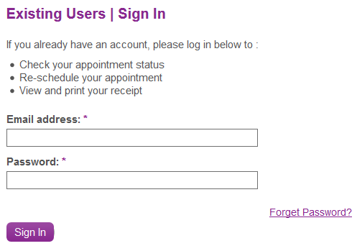
  - To finish scheduling an appointment, click Continue.
- On the Personal Information page, begin entering the volunteer’s information based on a valid form of ID using their full, legal name. Then click Save and Continue at the bottom of the page.
*NOTE: All boxes with a star next to the name must be completed to continue with the process. If you do not have all of the information available, click Save and Continue at the bottom of the page. Red boxes will appear next to required information. Then click Logout at the top of the page and the information will be saved.
- On the Personal Information and Demographics page, fill in the boxes with the information provided by the volunteer and must match a valid form of ID. Then click Save and Continue.
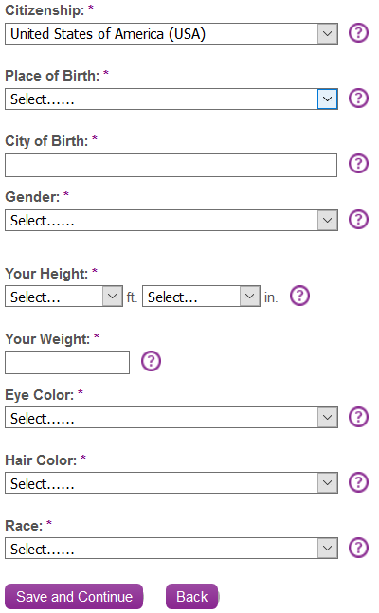
- On the Employer page, enter the Coconino, Mohave, or Yavapai office address and phone number. Then click Save and Continue.
  - For Yavapai 4-H volunteers, use the following name: University of Arizona Yavapai County 4-H Youth Development
  - For MG volunteers, use the following name: University of Arizona <county name> Master Gardener Volunteer Program
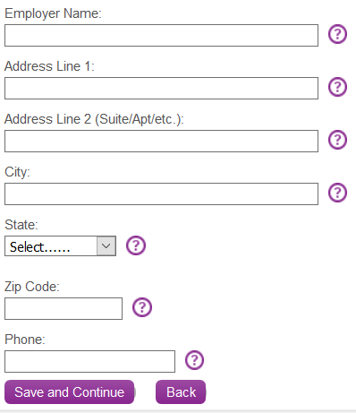
- On the Release and Privacy page, the DCC volunteer needs to read the disclaimer statement and agree to the terms. Check the I Agree boxes and fill in the remaining boxes. Then click Continue.
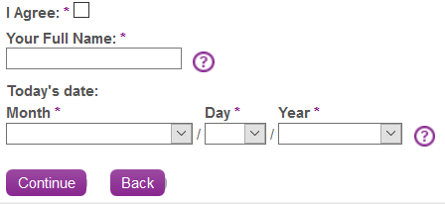
- In the search box, enter an address or select from one of two options above the search box to find a fingerprinting center. Then click Find.
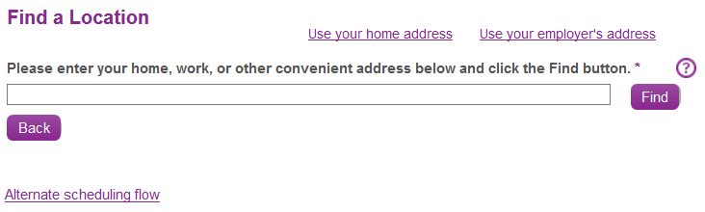
- Find the desired printing center and click Schedule Appointment.
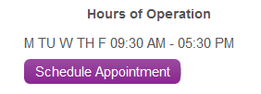
- Click a date on the calendar shown and select a time from one of the three dropdown boxes, then click Schedule. A pop box will ask to verify the date, time, and location information. If the information is correct, click Continue.
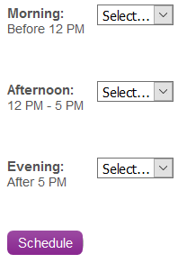
- On the Payment page, enter your PCard information. Once all of the information is verified and correct, click Make a Payment and Finish button at the bottom of the page.
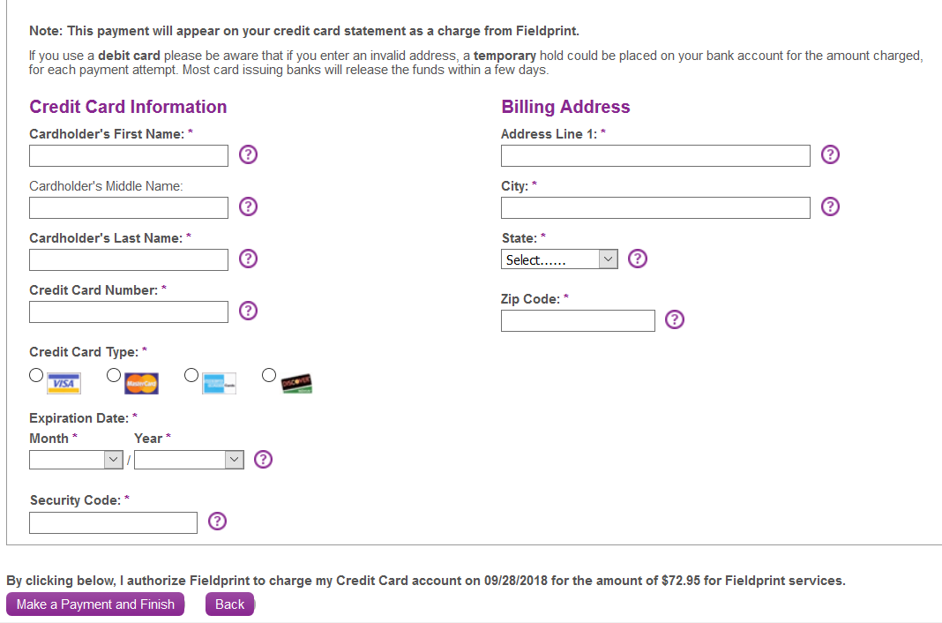
- Once the payment page is loaded, click on Print Receipt to the right of the page. Print two copies, one for the PCard transaction and one for the volunteer.
- Attach the receipt to a PCard form and submit for reconciliation.
Additional Instructions
- For Yavapai 4-H volunteers, write the date of the scheduled appointment at the top of the fingerprint form and return the volunteer’s folder to Shirley.
- Request that all volunteers return to the office to submit a copy of their DPS cards.

